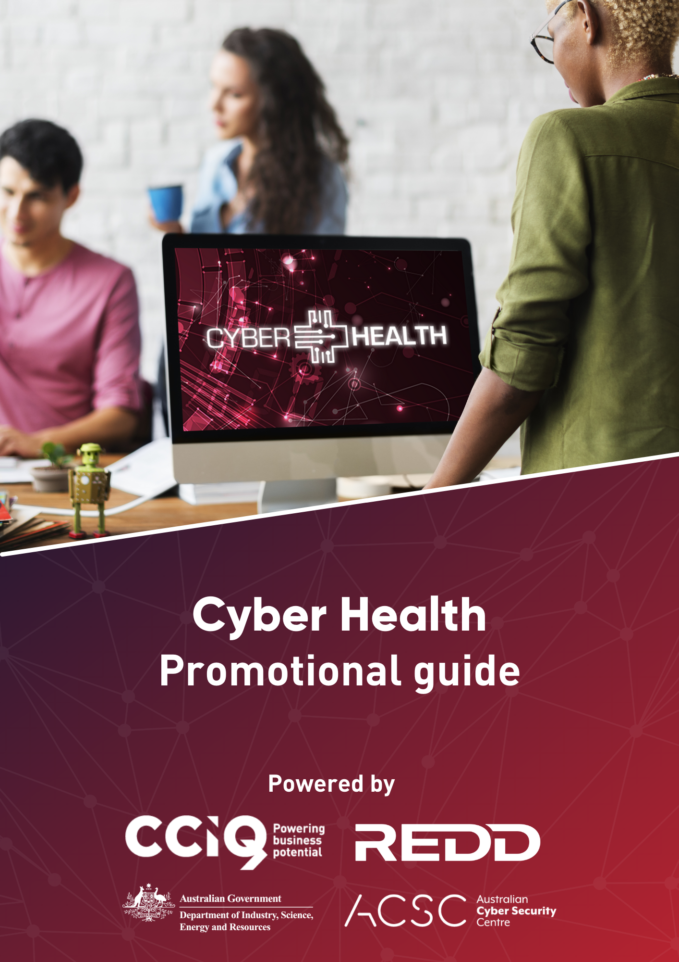
About Cyber Health
The Cyber Health program is powered by the Chamber of Commerce and Industry Queensland (CCIQ) and REDD Digital, and fully funded by the Department of Industry, Science, Energy & Resources. Content and resources are courtesy of the Australian Cyber Security Centre (ACSC).
Why educating businesses on cyber security is critical:
- Australian businesses lose $29 billion each year due to cyber attacks
- Every 10 minutes a cyber security incident is reported, with approximately 144 reports of cyber crime each day
- Many businesses underestimate the recovery time from a cyber security incident.

Cyber Health website
The Cyber Health website is home to various free resources to equip businesses with the tools and information to combat cyber security risks. Visit cyberhealth.com.au to learn more.
Cyber security assessment tool
Businesses can use the free online Cyber Assessment tool powered by BrightREDD to identify gaps in their cyber security. Selected businesses whose results indicate their cyber health needs a boost will be chosen to complete a more in-depth Cyber Vulnerability Audit, with limited places available.
CTRL + click here to learn more about the Cyber Assessment tool.
Educational videos and resources
To help reduce the risk of cyber security incidents, the Cyber Health program has a range of free online educational resources available to businesses. Included is a 24 video tutorial series that summarises all the cyber security essentials in a digestible format.
CTRL + click here to view the video tutorial playlist.
Free workshops across Queensland
Cyber Health are running free workshops across Queensland to educate businesses on cyber security essentials. Led by digital experts from REDD, the workshops will cover:
- How to combat cyber security risks to your business
- Enhance your business’ cyber security with a FREE cyber health tool
- Key resources to educate your team on cyber security best practice.
CTRL + click here to view our upcoming workshops.

Table of Contents
About Cyber Health 1
Cyber Health website 1
Digital artwork 3
Social media 3
Email marketing 5
Workshops 7
Thank you! 7

Digital artwork
We have prepared some artwork to help you promote the Cyber Health workshop across your social media, website, and email marketing activities.
CTRL + click here to download our artwork available for your use.

Social media
Cyber Health social media pages
- Facebook
- LinkedIn
- YouTube
#StayCyberSafe
As part of the Cyber Health launch across social media, we want to encourage businesses to use the hashtag #StayCyberSafe with any social media posts referring to the Cyber Health program.
Launch video
We have also prepared a video to promote the launch of the Cyber Health program, available for you to share across your social media.
CTRL + click here to watch our launch video on YouTube.

Suggested social media post copy
We have prepared some suggested copy for social media activity promoting the Cyber Health program.
Australian businesses lose $29 billion each year due to cyber attacks. Is your business protected?
Not only can a cyber breach cost your business a lot of money, they can also damage your brand’s reputation and cause long-term effects.
However, there are measures you can put in place now to protect your business – and @Cyber Health is here to help.

Powered by CCIQ and REDD, Cyber Health has various free tools and resources to help secure your business, including:
- 24 online video tutorials on cyber security essentials
- 5 minute Cyber Assessment tool
- Free Cyber Vulnerability Audit
- Free workshops across Queensland

Visit cyberhealth.com.au to start protecting your business.

Example social media post
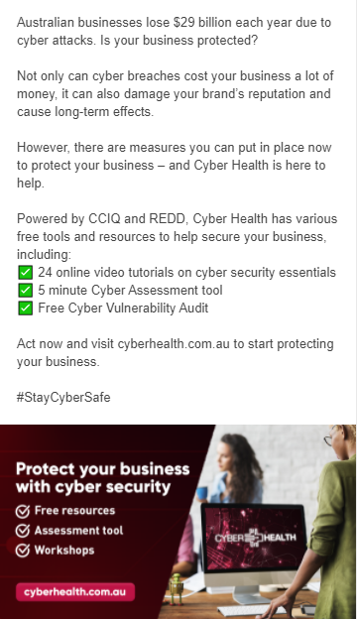

Email marketing
We have prepared communications for an eDM, an eDM banner and an email signature to help you promote the Cyber Health program to your members and networks.
Suggested eDM copy
Australian businesses lose $29 billion annually to cyber attacks.
Is your business protected?
Cyber security attacks are a real threat for Queensland businesses, and breaches could mean your reputation, confidence, data and secure information and budget are on the line.
However, there are measures you can put in place now to protect your business – and Cyber Health is here to help.
CCIQ and REDD are delivering Cyber Health, a free cyber security program with resources and tools to help you secure your business. The program is funded through the Department of Industry, Science, Energy & Resources.

Reduce the risk of cyber attacks to your business with Cyber Health’s range of free tools and educational resources:
- 24 online video tutorials on cyber security essentials
- 5 minute Cyber Assessment tool
- Free Cyber Vulnerability Audit
- Workshops across Queensland

Visit cyberhealth.com.au to start protecting your business

Email signature banner
CTRL + click here to download the email signature banner.

How to update your email signature on Outlook
Follow these steps to update your email signature banner:
- Download the Cyber Health workshop PNG image
- Click ‘File’ in the top left hand corner
- Click ‘Options’ in the bottom left hand corner
- Select ‘Mail’ on the left if it isn’t already selected
- Click ‘Signatures’ on the left
- Ensure your email signature is selected.
- Where you can edit your signature, click underneath your existing signature.
- Click the computer and image icon circled below and select the computer/photo icon.
- Upload the provided banner provided
- Click ‘Okay’
- Right click the image
- Click ‘Link’ from the drop down menu
- Select ‘Existing File or Web Page’ from the left menu
- Paste in the following link: https://cyberhealth.com.au/
- Click ‘Okay’

Once updated, your email signature should look like this:

Workshops
Cyber Health are running free workshops across Queensland to educate businesses on cyber security essentials. Led by digital experts from REDD, the workshops will cover:
- How to combat cyber security risks to your business
- Enhance your business’ cyber security with a free cyber health tool
- Key resources to educate your team on cyber security best practice.
CTRL + click here to view our upcoming workshops.

For Chambers who are hosting a workshop, we have prepared some artwork to help you promote the Cyber Health workshop and program.
CTRL + Click here to download our artwork available for your use.

Thank you!
Thank you for your participation in educating Queensland businesses on cyber security. We appreciate your help amplifying the Cyber Health program and equipping businesses with the tools they need to enhance their cyber security.

Have any questions? We’re here to help.
Karen Fitzgibbons
CCIQ General Manager of Commercial Operations
07 3192 0130
kfitzgibbons@cciq.com.au

Zoe Gell
CCIQ Marketing Manager
zgell@cciq.com.au

Paul Garcia
CCIQ Relationships Manager
07 3192 0138
pgarcia@cciq.com.au

